PYTHON PROGRAMMING LAB FILE

NAME : Khushi Sharma
Roll No. : 24/SCA/BCA(AIML)/031
Class : BCA (AIML) IIIC
SUBMITTED TO : Dr. Sakshi Gupta Ma’am

Q1. Write a python program to calculate number of days between two dates. Sample dates: (2014,7,2) , (2014,7,11)
Ans. Input :-
from datetime import date

date1 = date(2014, 7, 2)
date2 = date(2014, 7, 11)

delta = date2 - date1

print("Number of days between the two dates:", delta.days)

Output :-
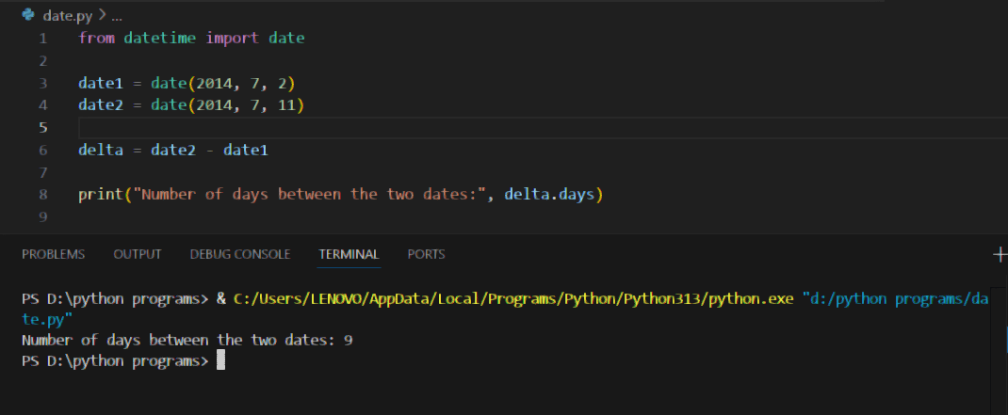

Q2. Write a python program that accepts an integar (n) and computes the value of n+nn+nnn
Ans. Input :-
n = int(input("Enter an integer: "))
n1 = int(f"{n}")
n2 = int(f"{n}{n}")
n3 = int(f"{n}{n}{n}")

result = n1 + n2 + n3

print("The result of n + nn + nnn is:", result)
Output :-
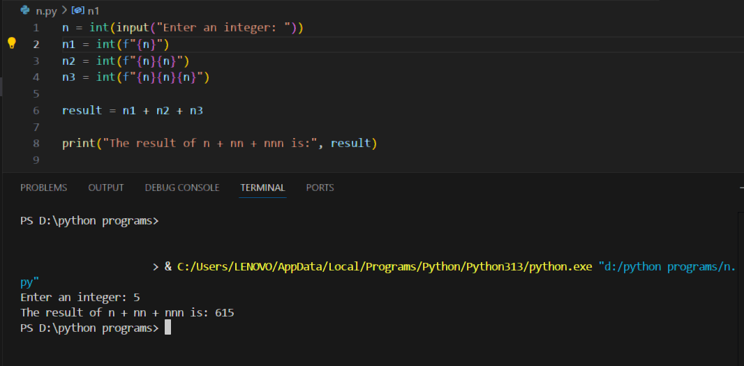

Q3. Ask the user for a number. Depending on whether the number is even or odd, print out an appropriate message to the user.
Ans. Input :-
num = int(input("Enter a number: "))

if num % 2 == 0:
print("The number is even.")
else:
print("The number is odd.")

Output :-
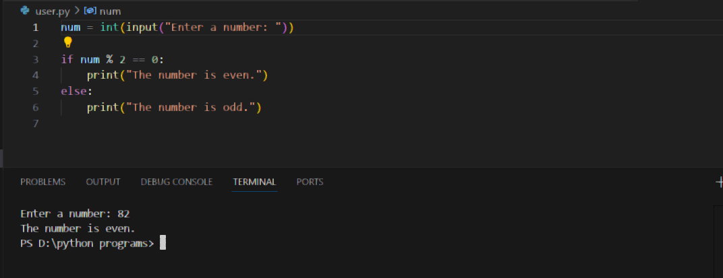

Q4. Write a Python program which accepts a sequence of comma-separated numbers from user and generate a list and a tuple with those numbers.
Ans. Input :-
numbers = input("Enter comma-separated numbers: ")

num_list = numbers.split(",")

num_tuple = tuple(num_list)

print("List:", num_list)
print("Tuple:", num_tuple)

Output :-
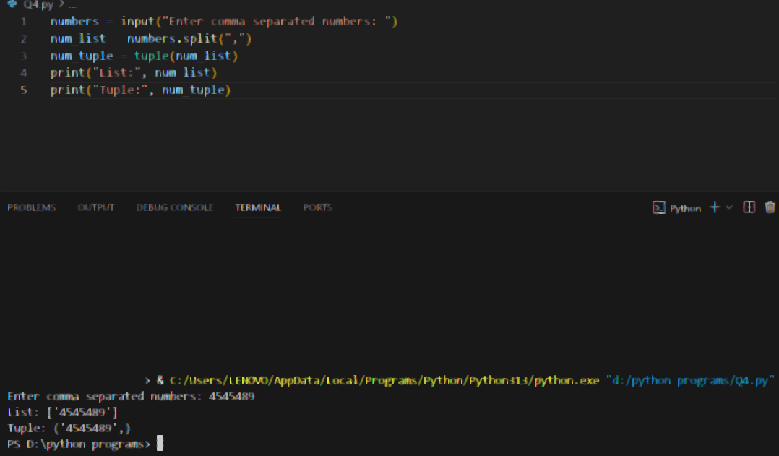

Q5. Write a Python program to calculate the sum of three given numbers, if the values are equal then return thrice of their sum.
Ans. Input :
num1 = int(input("Enter first number: "))
num2 = int(input("Enter second number: "))
num3 = int(input("Enter third number: "))
total = num1 + num2 + num3
if num1 == num2 == num3:
total = total * 3
# Display the result
print("The result is:", total)
Output :
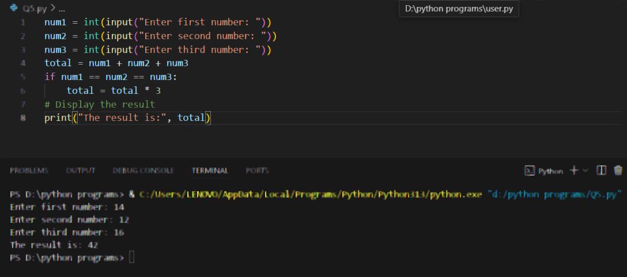

Q6. Write a Python program to test whether a passed letter is a vowel or not.
Ans. Input :
letter = input("Enter a letter: ").lower()
if letter in ('a', 'e', 'i', 'o', 'u'):
print("It is a vowel.")
else:
print("It is not a vowel.")
Ouput :
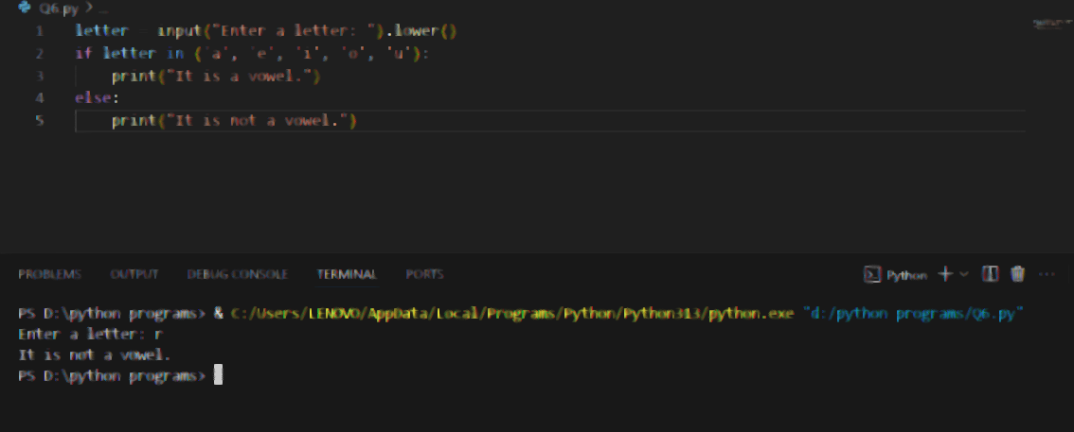

Q7. Take a list, say for example this one:
a = [1, 1, 2, 3, 5, 8, 13, 21, 34, 55, 89]
and write a program that prints out all the elements of the list that are less than 5.
Extras:
- Instead of printing the elements one by one, make a new list that has all the elements less than 5 from this list in it and print out this new list.

Input :
a = [1, 1, 2, 3, 5, 8, 13, 21, 34, 55, 89]
new_list = [i for i in a if i < 5]
print("Elements less than 5:", new_list)
Output:
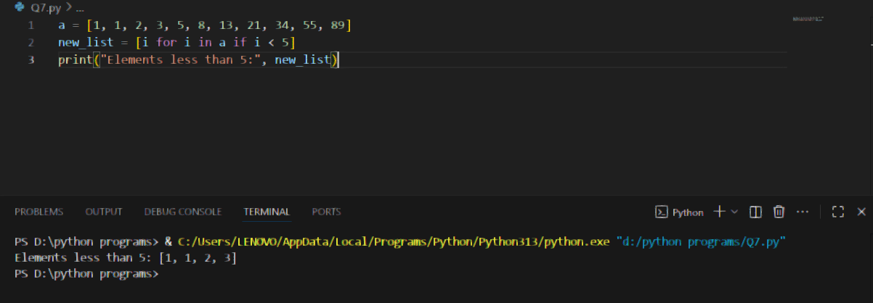b) Write this in one line of Python.

Input :
print([i for i in [1, 1, 2, 3, 5, 8, 13, 21, 34, 55, 89] if i < 5])

Output:
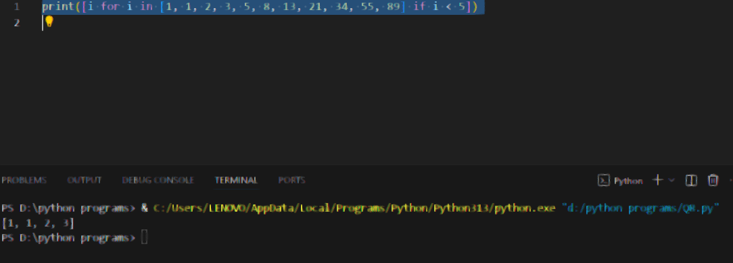

c)Ask the user for a number and return a list that contains only elements from the original list a that are smaller than that number given by the user.
Input :
a = [1, 1, 2, 3, 5, 8, 13, 21, 34, 55, 89]
num = int(input("Enter a number: "))
new_list = [i for i in a if i < num]
print("Numbers smaller than", num, "are:", new_list)

Output:

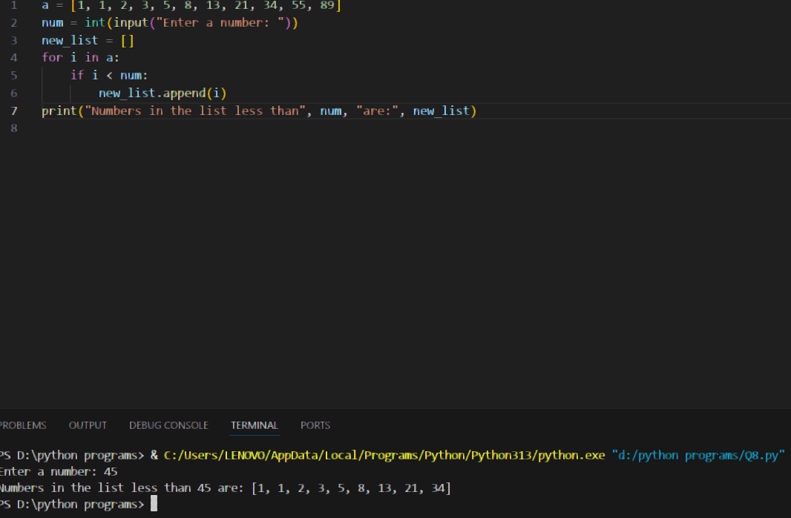

Q 8. Create a program that asks the user for a number and then prints out a list of all the divisors of that number. (If you don’t know what a divisor is, it is a number that divides
evenly into another number. For example, 13 is a divisor of 26 because 26 / 13 has no remainder.)
Ans -
Input :
num = int(input("Enter a number: "))
divisors = []
for i in range(1, num + 1):
if num % i == 0:
divisors.append(i)
print("The divisors of", num, "are:", divisors)

Output:
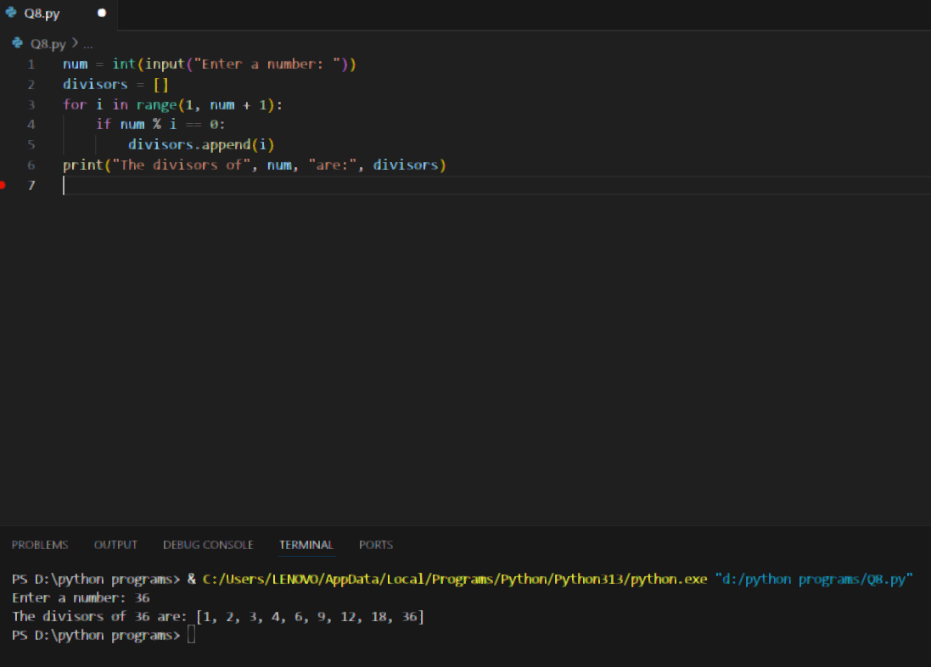

Q 9. Take two lists, say for example these two:
a = [1, 1, 2, 3, 5, 8, 13, 21, 34, 55, 89]
b = [1, 2, 3, 4, 5, 6, 7, 8, 9, 10, 11, 12, 13]
and write a program that returns a list that contains only the elements that are common between the lists (without duplicates). Make sure your program works on two lists of
different sizes.
Ans –
Input :
a = [1, 1, 2, 3, 5, 8, 13, 21, 34, 55, 89]
b = [1, 2, 3, 4, 5, 6, 7, 8, 9, 10, 11, 12, 13]
common = [i for i in set(a) if i in b]
print("Common elements are:", common)

Output :
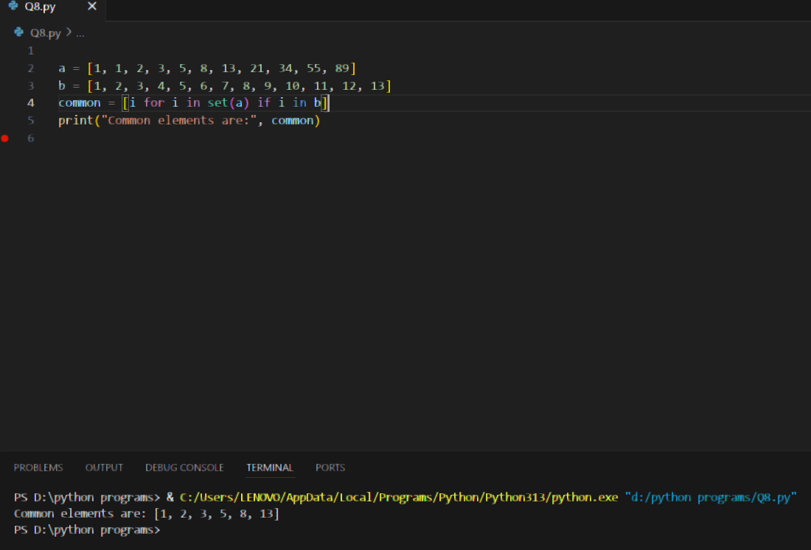

Q 10. Ask the user for a string and print out whether this string is a palindrome or not. (A palindrome is a string that reads the same forwards and backwards.).
Ans –
Input :
word = input("Enter a string: ")
if word == word[::-1]:
print("Yes, it's a palindrome!")
else:
print("No, it's not a palindrome.")
Output : 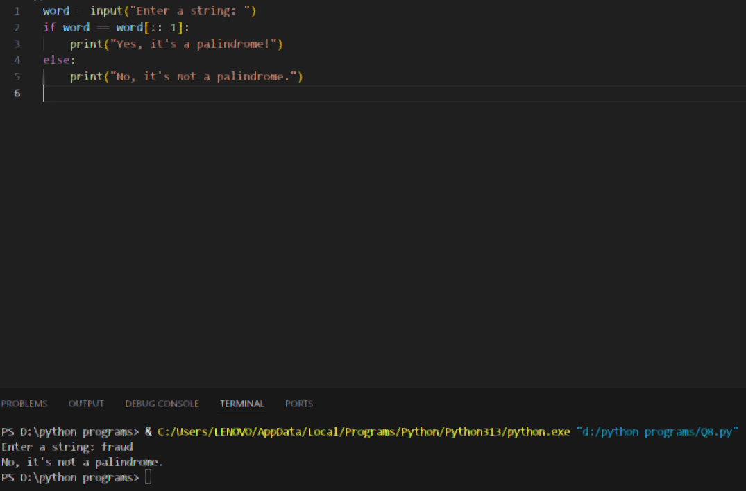

Q 11. Let’s say I give you a list saved in a variable: a = [1, 4, 9, 16, 25, 36, 49, 64, 81, 100]. Write one line of Python that takes this list a and makes a new list that has only the even elements of this list in it.
Ans –
Input :
a = [1, 4, 9, 16, 25, 36, 49, 64, 81, 100]
even_elements = [i for i in a if i % 2 == 0]
print(even_elements)
Output :
